UNITED STATES
SECURITIES AND EXCHANGE COMMISSION
WASHINGTON, D.C. 20549

FORM 8-K

CURRENT REPORT
Pursuant to Section 13 or 15(d)
of The Securities Exchange Act of 1934
Date of Report (Date of Earliest Event Reported): September 20, 2026

Cue Biopharma, Inc.
(Exact name of registrant as specified in its charter)

Delaware |  | 001-38327 |  | 47-3324577
(State or other jurisdiction  of incorporation) |  | (Commission  File Number) |  | (IRS Employer  Identification No.)

40 Guest Street  Boston, Massachusetts |  | 02135
(Address of principal executive offices) |  | (Zip Code)
(617) 949-2680
(Registrant’s telephone number, including area code)
(Former name or former address, if changed since last report.)

Check the appropriate box below if the Form 8-K filing is intended to simultaneously satisfy the filing obligation of the registrant under any of the following provisions (see General Instruction A.2. below):

☐ | Written communications pursuant to Rule 425 under the Securities Act (17 CFR 230.425)

☐ | Soliciting material pursuant to Rule 14a-12 under the Exchange Act (17 CFR 240.14a-12)

☐ | Pre-commencement communications pursuant to Rule 14d-2(b) under the Exchange Act (17 CFR 240.14d-2(b))

☐ | Pre-commencement communications pursuant to Rule 13e-4(c) under the Exchange Act (17 CFR 240.13e-4(c))
Securities registered pursuant to Section 12(b) of the Act:

Title of each class |  | Trading  Symbol(s) |  | Name of each exchange  on which registered
Common Stock, par value $0.001 per share |  | CUE |  | Nasdaq Capital Market
Indicate by check mark whether the registrant is an emerging growth company as defined in Rule 405 of the Securities Act of 1933 (§230.405 of this chapter) or Rule 12b-2 of the Securities Exchange Act of 1934 (§240.12b-2 of this chapter).
Emerging growth company ☐
If an emerging growth company, indicate by check mark if the registrant has elected not to use the extended transition period for complying with any new or revised financial accounting standards provided pursuant to Section 13(a) of the Exchange Act. ☐

Item 7.01. | Regulation FD Disclosure.
On September 20, 2026, Cue Biopharma, Inc. (the “Company”) issued a press release announcing positive topline results from a Phase 2 clinical trial of CUE-221 in Chronic Spontaneous Urticaria, or CSU, as discussed in Item 8.01 of this Current Report on Form 8-K. A copy of the press release is furnished as Exhibit 99.1 to this Current Report on Form 8-K.
The Company is hosting a conference call and live webcast to discuss the clinical data on September 21, 2026 at 8:00 a.m. E.T. The Company has made available a slide presentation to accompany the call, a copy of which is being furnished as Exhibit 99.2 to this Current Report on Form 8-K.
The information in Item 7.01 of this Current Report on Form 8-K, including Exhibits 99.1 and 99.2 attached hereto, is intended to be furnished and shall not be deemed “filed” for purposes of Section 18 of the Securities Exchange Act of 1934, as amended (the “Exchange Act”), or otherwise subject to the liabilities of that section, nor shall it be deemed incorporated by reference in any filing under the Securities Act of 1933, as amended, or the Exchange Act, except as expressly set forth by specific reference in such filing.

Item 8.01. | Other Events.
Phase 2 Chronic Spontaneous Urticaria Study Topline Results
On September 20, 2026, the Company announced positive topline data from a Phase 2 clinical trial of CUE-221 in CSU conducted in China by Genesis Life Sciences, an affiliate of Ascendant Health Ltd. This Phase 2 clinical trial enrolled 145 participants with moderate to severe CSU whose disease remained inadequately controlled despite treatment with H1-antihistamines.
The Phase 2 multicenter, randomized, double-blind, placebo and active comparator-controlled study was conducted in China and included a 16-week treatment period with a 20-week follow-up period post-treatment. Patients were randomized in a 2:2:2:1:1 ratio across five treatment groups to either subcutaneously delivered CUE-221 at 4 mg/kg, 2 mg/kg, or 1 mg/kg Q4W, or placebo Q4W, or omalizumab 300 mg Q4W. The primary endpoint was the proportion of patients who achieved HSS7=0 at week 12. A key secondary endpoint assessed complete response, defined as the proportion of patients who achieved UAS7=0 at week 12. The study was designed to test superiority over placebo. Omalizumab was included to enable comparative efficacy without planned statistical testing.
The primary endpoint of percentage of patients with HSS7=0 at week 12 was dose-responsive and met at all dose levels. The key secondary endpoint of percentage of patients with UAS7=0 at week 12 was dose responsive and met statistical significance at the 4 mg/kg highest dose level.

Primary Endpoint of HSS7=0 at Week 12
 |  | CUE-221 (Q4W) |  |  |  |  |  |  |  |  |  |  |  | Placebo  Q4W |  |  |  | Omalizumab  Q4W
 |  | 4 mg/kg  (N=35) |  |  |  | 2 mg/kg  (N=36) |  |  |  | 1 mg/kg  (N=37) |  |  |  | (N=18) |  |  |  | 300 mg  (N=17)
Complete Resolution of Hives (HSS7=0) |  |  | 54 | % |  |  | 53 | % |  |  | 43 | % |  |  | 11 | % |  |  | 41 | %
95% Confidence Interval |  |  | (37%, 71% | ) |  |  | (36%, 70% | ) |  |  | (27%, 61% | ) |  |  | (1%, 35% | ) |  |  | (18%, 67% | )
P-values (vs. placebo) |  |  | p < 0.005 |  |  |  | p < 0.005 |  |  |  | p < 0.05 |  |  |  | NA |  |  |  | Not Tested
P-values based on Fisher’s exact test; Clopper-Pearson 95% confidence interval

Key Secondary Endpoint of UAS7=0 at Week 12
 |  | CUE-221 (Q4W) |  |  |  |  |  |  |  |  |  |  |  | Placebo  Q4W |  |  |  | Omalizumab  Q4W
 |  | 4 mg/kg  (N=35) |  |  |  | 2 mg/kg  (N=36) |  |  |  | 1 mg/kg  (N=37) |  |  |  | N=18 |  |  |  | 300 mg  (N=17)
Complete Response (UAS7=0) |  |  | 46 | %* |  |  | 39 | % |  |  | 38 | % |  |  | 11 | % |  |  | 29 | %
95% Confidence Interval |  |  | (29%, 63% | ) |  |  | (23%, 57% | ) |  |  | (23%, 55% | ) |  |  | (1%, 35% | ) |  |  | (10%, 56% | )

* | p<0.05 P-values based on Fisher’s exact test; Clopper-Pearson 95% confidence interval

The percentage of participants who achieved HSS7=0 further increased beyond the Week 12 primary endpoint, peaking at Week 22 across all CUE-221 dose groups. After a last dose was administered for all groups at Week 16, clinically meaningful benefit was maintained for up to 12 weeks off treatment (through week 28) at the 4 mg/kg dose level. A higher rate of complete resolution of hives was observed for the 4 mg/kg dose group relative to the lower dose groups and placebo, and post hoc analysis at Week 28 demonstrated a statistically significant difference versus omalizumab (delta = 36%), supporting the premise of fundamental difference between CUE-221 and omalizumab with respect to impacts on disease biology.

Complete Resolutions of Hives at Primary Endpoint, Peak Effect, and 12 Weeks Off Drug
 |  | CUE-221 (Q4W) |  |  |  |  |  |  |  |  |  |  |  | Placebo  Q4W |  |  |  | Omalizumab  Q4W |  |  |  | CUE 4mg/kg vs.  Omalizumab
Time |  | 4 mg/kg |  |  |  | 2mg/kg |  |  |  | 1 mg/kg |  |  |  | Placebo |  |  |  | 300 mg |  |  |  | Δ in Percent
Week 12 Primary |  |  | 54 | % |  |  | 53 | % |  |  | 43 | % |  |  | 11 | % |  |  | 41 | % |  |  | 13 | %
Week 22 Peak Effect |  |  | 69 | % |  |  | 61 | % |  |  | 57 | % |  |  | 11 | % |  |  | 41 | % |  |  | 28 | %
Week 28 12 weeks off drug |  |  | 60 | % |  |  | 31 | % |  |  | 24 | % |  |  | 11 | % |  |  | 24 | % |  |  | 36 | %*

* | p<0.05 P-values based on Fisher’s exact test
Demographics and baseline disease characteristics were generally well balanced across treatment groups. CUE-221 demonstrated a favorable safety profile. There were no treatment-related serious adverse events and no cases of hypersensitivity reactions including anaphylaxis. Injection site reactions (ISR) were infrequent, only one ISR was > grade 1, and none led to study discontinuation.
The Company believes these findings support continued clinical development of CUE-221 as a product candidate for CSU and will also continue with plans for development in food allergy. The Company recently submitted an IND to the U.S. Food and Drug Administration (FDA) for food allergy and, subject to the FDA’s review of the sufficiency of the data from the Phase 2 clinical trial of CUE-221 in CSU, the Company intends to initiate a Phase 2 trial of CUE-221 in food allergy and a Phase 2b/3 trial in CSU.
Forward-Looking Statements
The Company cautions you that statements contained in this Current Report on Form 8-K regarding matters that are not historical facts are forward-looking statements. These statements are based on the Company’s current beliefs and

expectations and upon what management believes to be reasonable assumptions based on information currently available to it. These forward-looking statements include, but are not limited to, statements regarding: the potential of CUE-221, including its potential future benefit to patients, the Company’s plans with respect to CUE-221, including the initiation of a Phase 2b/3 clinical trial in CSU and a Phase 2 clinical trial in food allergy and the timings thereof; the Company’s expectations regarding the presentation of full clinical data from the Phase 2 CUE-221 trial, and the Company’s expectations regarding the Company’s growth; the Company’s business strategies, plans, and prospects; and other risks described from time to time in the “Risk Factors” section of its filings with the U.S. Securities and Exchange Commission (the “SEC”), including those described in its Annual Report on Form 10-K, its Quarterly Reports on Form 10-Q, and in future filings the Company makes with the SEC. You are cautioned not to place undue reliance on these forward-looking statements, which speak only as of the date of this Current Report on Form 8-K, and the Company undertakes no obligation to update these statements to reflect events that occur or circumstances that exist after the date of this Current Report on Form 8-K. All forward-looking statements are qualified in their entirety by this cautionary statement, which is made under the safe harbor provisions of the Private Securities Litigation Reform Act of 1995.

Item 9.01. | Financial Statements and Exhibits.
(d) Exhibits:

Exhibit  No. |  | Description
99.1 |  | Press Release issued by Cue Biopharma, Inc. on September 20, 2026.
99.2 |  | Corporate Presentation.
104 |  | Cover Page Interactive Data File (embedded within the Inline XBRL document)

SIGNATURES
Pursuant to the requirements of the Securities Exchange Act of 1934, the Registrant has duly caused this report to be signed on its behalf by the undersigned hereunto duly authorized.

 |  |  |  | Cue Biopharma, Inc.
Date: September 21, 2026 |  |  |  | By: |  | /s/ Shao-Lee Lin
 |  |  |  | Name: Shao-Lee Lin
Title: President and Chief Executive Officer
(Principal Executive Officer)
Exhibit 99.1


Cue Biopharma Announces Positive Topline Results from CUE-221 Phase 2 Study in Chronic
Spontaneous Urticaria
Results support potential for differentiated clinical impact for patients suffering from chronic
hives and advancement to Phase 2b/3 registration enabling study

 |  |  | Primary endpoint and the key secondary endpoint were met with high statistical significance and CUE-221 demonstrated an overall favorable safety profile

 |  |  | Clinically different efficacy profile observed relative to XOLAIR® (omalizumab) highlights potential for a fundamental mechanism-based biological difference

 |  |  | Cue Biopharma to host conference call on Monday, September 21, at 8:00 a.m. EDT
BOSTON, Sept. 20, 2026 (GLOBE NEWSWIRE) – Cue Biopharma (Nasdaq: CUE) a clinical-stage biopharmaceutical company targeting transformative therapies for immune-mediated diseases today announced positive topline results from the Phase 2 clinical trial of CUE-221 (UB-221) conducted in China by Genesis Life Sciences, a related company of Ascendant Health Limited (Ascendant). The trial enrolled 145 participants with moderate to severe chronic spontaneous urticaria (CSU), a disease resulting in chronic hives, that remained inadequately controlled despite treatment with H1 antihistamines.
“We are excited to share these positive results which we believe establish CUE-221 as a potential best therapeutic option for patients suffering with chronic spontaneous urticaria,” said Shao-Lee Lin, M.D., Ph.D., President and Chief Executive Officer of Cue Biopharma. “These findings reinforce our enthusiasm for the precision engineered, unique dual mechanism of action of CUE-221, reflecting science that is truly differentiated. Based on the strength of these data, we are working toward the rapid initiation of a Phase 2b/3 study in CSU and continuing to advance a planned Phase 2 study in food allergy. We thank the patients, investigators, and study staff, all of whom made these results possible. We look forward to presenting the complete data set including PK and IgE analyses from this 36-week study at an upcoming scientific meeting.”

Phase 2 CSU Study Topline Results
The Phase 2 multicenter, randomized, double-blind, placebo and active comparator-controlled study was conducted in China and included a 16-week treatment period with a 20-week follow-up period post-treatment. Patients were randomized in a 2:2:2:1:1 ratio across five treatment groups to either subcutaneously deliver CUE-221 at 4 mg/kg, 2 mg/kg, or 1 mg/kg Q4W, or placebo Q4W, or omalizumab 300 mg Q4W. The primary endpoint was the proportion of patients who achieved HSS7=0 at week 12. A key secondary endpoint assessed complete response, defined as the proportion of patients who achieved UAS7=0 at week 12. The study was designed to test superiority over placebo. Omalizumab was included to enable comparative efficacy without planned statistical testing.
The primary endpoint of percentage of patients with HSS7=0 at week 12 was dose-responsive and met at all dose levels. The key secondary endpoint of percentage of patients with UAS7=0 at week 12 was dose responsive and met statistical significance at the 4 mg/kg highest dose level.
Primary Endpoint of HSS7=0 at Week 12

 |  | CUE-221 (Q4W) |  |  |  |  |  | Placebo  Q4W |  | Omalizumab  Q4W
 |  | 4 mg/kg  (N=35) |  | 2 mg/kg  (N=36) |  | 1 mg/kg  (N=37) |  | (N=18) |  | 300 mg  (N=17)
Complete Resolution of Hives (HSS7=0) |  | 54% |  | 53% |  | 43% |  | 11% |  | 41%
95% Confidence Interval |  | (37%, 71%) |  | (36%, 70%) |  | (27%, 61%) |  | (1%, 35%) |  | (18%, 67%)
P-values (vs placebo) |  | p < 0.005 |  | p < 0.005 |  | p < 0.05 |  | NA |  | Not Tested
P-values based on Fisher’s exact test; Clopper-Pearson 95% confidence interval
Key Secondary Endpoint of UAS7=0 at Week 12

 |  | CUE-221 (Q4W) |  |  |  |  |  | Placebo  Q4W |  | Omalizumab  Q4W
 |  | 4 mg/kg  (N=35) |  | 2 mg/kg  (N=36) |  | 1 mg/kg  (N=37) |  | N=18 |  | 300 mg  (N=17)
Complete Response (UAS7=0) |  | 46%* |  | 39% |  | 38% |  | 11% |  | 29%
95% Confidence Interval |  | (29%, 63%) |  | (23%, 57%) |  | (23%, 55%) |  | (1%, 35%) |  | (10%, 56%)

* | p<0.05 P-values based on Fisher’s exact test; Clopper-Pearson 95% confidence interval
The percentage of participants who achieved HSS7=0 further increased beyond the Week 12 primary endpoint, peaking at Week 22 across all CUE-221 dose groups. After a last dose was administered for all groups at Week 16, clinically meaningful benefit was maintained for up to 12 weeks off treatment (through week 28) at the 4 mg/kg dose level. A higher rate of complete resolution of hives was observed for the 4 mg/kg dose group relative to the lower dose groups and placebo, and post hoc analysis at Week 28 demonstrated a statistically significant difference versus omalizumab (delta = 36%), supporting the premise of fundamental difference between CUE-221 and omalizumab with respect to impacts on disease biology.

Complete Resolutions of Hives at Primary Endpoint, Peak Effect, and 12 Weeks Off Drug

 |  | CUE-221 (Q4W) |  |  |  |  |  | Placebo  Q4W |  | Omalizumab  Q4W |  | CUE 4mg/kg  vs.Omalizumab
Time |  | 4 mg/kg |  | 2mg/kg |  | 1 mg/kg |  | Placebo |  | 300 mg |  | Δ in Percent
Week 12 Primary |  | 54% |  | 53% |  | 43% |  | 11% |  | 41% |  | 13%
Week 22 Peak Effect |  | 69% |  | 61% |  | 57% |  | 11% |  | 41% |  | 28%
Week 28 12 weeks off drug |  | 60% |  | 31% |  | 24% |  | 11% |  | 24% |  | 36%*

* | p<0.05 P-values based on Fisher’s exact test
Demographics and baseline disease characteristics were generally well balanced across treatment groups. CUE-221 demonstrated a favorable safety profile. There were no treatment-related serious adverse events and no cases of hypersensitivity reactions including anaphylaxis. Injection site reactions (ISR) were infrequent, only one ISR was > grade 1, and none led to study discontinuation.
“The results of the Phase 2 CUE-221 study in patients with CSU are particularly notable,” said Dale Umetsu, M.D., Ph.D., Clinical Professor of Medicine and former Chief of the Allergy and Immunology Division, Stanford University, Clinical Professor of Pediatrics, University of California, San Francisco and prior Global Lead for XOLAIR development. “First, the results after 12 weeks of treatment, after three doses, appear to indicate that CUE-221 was better than XOLAIR for CSU at all dose levels tested. Moreover, there was persistent improvement with the 4 mg/kg dose at week 28, which was 12 weeks off treatment, significantly better than that off of standard XOLAIR dosing. Finally, the safety data analyzed so far, show no major safety issues, which is not unexpected from an anti-IgE mAb.”
Dr. Umetsu added, “These results suggest that CUE-221, like XOLAIR is designed to prevent IgE from binding to FceR1 but unlike XOLAIR allows IgE to bind to CD23, may represent a critical advancement over XOLAIR. The results support that the effects of CUE-221 on IgE function could result in substantial efficacy in CSU that persists for several months, even after dosing ends. Since XOLAIR has represented the clear standard for all other CSU therapies, the possibility that CUE-221 may represent a clear improvement above that of XOLAIR is most impressive. That improvement in efficacy may be directly relevant for food allergy, another area where XOLAIR currently prevails as the standard-of-care.“

“I am very pleased to see these outstanding results from the UB-221 Phase 2 CSU trial,” said Tse-Wen Chang, Ph.D., innovator of XOLAIR as well as UB-221 and an international expert in IgE biology. “The UB-221 data provide clear clinical evidence validating the molecule’s design to not only directly neutralize IgE, but also to create a next-generation approach to eliminate the production of new IgE over time. This fundamental difference in biological mechanism that is now clinically evident cannot be reached by giving higher doses or more potent IgE neutralization. Having invented several novel IgE-targeting molecules that ultimately led to the creation of UB-221, I am encouraged by these emerging data and the potential for this approach to offer a meaningfully different path toward a functional treatment for IgE-mediated diseases.”
Webcast and Conference Call
Cue Biopharma will host a conference call and webcast on Monday, September 21 at 8:00 a.m. EDT to present the results. The event will be webcast live and can be accessed via the attached link below. https://edge.media-server.com/mmc/p/mjexxy37
About Dale Umetsu, M.D., Ph.D.
Dale Umetsu, M.D., Ph.D., Former chief of the allergy immunology division and tenured professor of pediatrics at Stanford University, and Former Prince al Saud Professor of Pediatrics AT Harvard Medical School. Dr. Umetsu also led global development of XOLAIR and the approval of XOLAIR for CSU and food allergy while at Genentech. Currently, he serves as a clinical professor of pediatrics at the University of California, San Francisco.
About Tse-Wen Chang, Ph.D.
Tse-Wen Chang, Ph.D., is a Taiwanese immunologist and pioneer in anti-IgE therapy. His early research into the immunoglobulin E (IgE) pathway and antibody-based therapeutics contributed to the development of omalizumab (XOLAIR), which is approved for the treatment of severe allergic asthma and severe chronic spontaneous urticaria. Dr. Chang is a cofounder of Tanox, a biopharmaceutical company focused on anti-IgE therapies for allergic diseases. He previously served as Dean of the College of Life Sciences at National Tsing Hua University in Taiwan and as Distinguished Research Fellow at the Genomics Research Center, Academia Sinica.
About Chronic Spontaneous Urticaria
CSU is a chronic inflammatory skin disease driven in part by type 2 inflammation, which causes sudden and debilitating hives and recurring itch. CSU is typically treated with H1 antihistamines, medicines that target H1 receptors on cells to control symptoms of itch and urticaria. However, the disease remains uncontrolled despite antihistamine treatment in many patients, some of whom are left with limited alternative treatment options. These individuals continue to experience symptoms that can be debilitating and significantly impact their quality of life.

About CUE-221
CUE-221 (Ascendant-221, UB-221) is a humanized anti-IgE IgG1 monoclonal antibody designed with a precision engineered dual mechanism of action. CUE-221 binds to IgE at sites that are distinct from the binding sites for other anti-IgE monoclonal antibodies. In doing so, it maintains the capacity of total IgE to bind the CD23 receptor at the surface of B cells, resulting in reduced IgE synthesis. Therefore, CUE-221 is a functionally distinct novel anti-IgE antibody designed to not only neutralize free IgE with high potency, but also prevents the synthesis of new IgE which could ultimately result in functional cure if IgE is eradicated. The CUE-221 Phase 2 clinical trial in CSU produced positive topline results and clinical evidence providing initial validation of the clinical potential of a precision engineered anti-IgE dual mechanism of action. The study also demonstrated fundamental biological differences compared to current therapies. Based on these data, we are planning to advance CUE-221 in a Phase 2b/3 study in chronic spontaneous urticaria and in a Phase 2 study in food allergy.
CUE-221 (UB-221) was innovated by Dr. Chang Tse Wen, a pioneer in the field of anti-IgE therapy, while serving as a Fellow of Academia Sinica. UB-221 was originally developed by United Biopharma (Holdings) Co., Ltd. (“United Biopharma”) with rights allocated between two of United Biopharma’s related companies, Genesis Life Sciences (“Genesis”) (China, Hong Kong, Macau and Taiwan, where Genesis continues development of the antibody under the name UB-221) and Ascendant Health Limited (“Ascendant”) (rest of world). Under an exclusive license agreement with Ascendant, Cue Biopharma obtained exclusive development, manufacturing, and commercialization rights in Ascendant’s rest of world territories.
About Cue Biopharma
Cue Biopharma (Nasdaq: CUE) is a clinical stage biopharmaceutical company focused on advancing a portfolio of potentially transformative therapies designed to enable functional cures across immunological disorders. Its lead asset, CUE-221, is a novel anti-IgE antibody with a dual mechanism of action design, moving into Phase 2b/3 development for allergic diseases. In addition, Cue developed the Immuno-STAT® platform which selectively targets disease-specific T cells in vivo without broad immune modulation. Its lead autoimmune candidate, CUE-401, has an investigational new drug application pending in the U.S. for a Phase 1 clinical trial. CUE-401 is designed to regulate inflammation and drive Treg-mediated tolerance. Cue is led by an experienced management team with deep expertise in identifying, acquiring, and advancing promising drug candidates.
About Ascendant Health Limited
Ascendant is a privately held biotechnology company committed to delivering transformative solutions to patients globally.

About Genesis Life Sciences
Genesis Life Sciences focuses on the innovative development of monoclonal antibody drugs. It is a biopharmaceutical company with a product line in late-stage clinical trials, specializing in the development of innovative monoclonal antibody drugs applicable to chronic infectious diseases, allergic diseases, and autoimmune diseases. Closely aligned with key national research projects and market demand, the company has introduced highly promising monoclonal antibody products, leveraging internal research capabilities and support from expert teams across various fields to accelerate the product launch and sales process. We care about human health and well-being, focus on unmet patient needs, and drive monoclonal antibody development through innovative thinking, ultimately sharing our results with partners and the public, striving to provide the best treatment for patients.
*XOLAIR® is a registered trademark of Novartis AG.
Cautionary Note Regarding Forward-Looking Statements
This press release contains forward-looking statements within the meaning of the Private Securities Litigation Reform Act of 1995. Such forward-looking statements include, but are not limited to, those regarding the potential of CUE-221, including its potential future benefit to patients, the company’s plans with respect to CUE-221, including the initiation of a Phase 2b/3 clinical trial in CSU and a Phase 2 clinical trial in food allergy and the timing thereof, the company’s expectations regarding the presentation of full clinical data from the Phase 2 CUE-221 trial, the company’s growth, and the company’s business strategies, plans, and prospects.
Forward-looking statements, which are based on certain assumptions and describe the company’s future plans, strategies and expectations, can generally be identified by the use of forward-looking terms such as “believe,” “expect,” “may,” “will,” “should,” “would,” “could,” “seek,” “intend,” “plan,” “goal,” “project,” “estimate,” “anticipate,” “strategy,” “future,” “likely,” “promise,” “potential” or other comparable terms, although not all forward-looking statements contain these identifying words. All statements other than statements of historical facts included in this press release regarding the company’s strategies, prospects, financial condition, operations, costs, plans, and objectives are forward-looking statements. Important factors that could cause the company’s actual results and financial condition to differ materially from those indicated in the forward-looking statements include, among others, the company’s ability to maintain and establish collaboration, licensing and other arrangements; the company’s limited operating history, limited cash and a history of losses; the company’s ability to achieve profitability; potential setbacks in the company’s research and development efforts for its current and future drug product candidates, including negative or inconclusive results from its preclinical studies or clinical trials or the company’s ability to replicate in later clinical trials positive results found in preclinical studies and early-stage clinical trials of its product candidates; serious and unexpected drug-related side effects or other safety issues experienced by participants in clinical trials; potential challenges associated with clinical trials conducted in China and the company’s access to, and acceptability of, the data therefrom; its ability to secure required U.S. Food and Drug Administration (“FDA”) or other governmental approvals for its product candidates and the breadth of any approved indication; delays and changes in regulatory

requirements, policy and guidelines including potential delays in submitting required regulatory applications to the FDA; the company’s reliance on licensors, collaborators, contract research organizations, suppliers and other business partners; the company’s ability to obtain adequate financing to fund its business operations in the future; the company’s ability to maintain and enforce necessary patent and other intellectual property protection; competitive factors; general economic and market conditions and the other risks and uncertainties described in the Risk Factors and Management’s Discussion and Analysis of Financial Condition and Results of Operations sections of the company’s most recently filed Annual Report on Form 10-K and any subsequently filed Quarterly Report(s) on Form 10-Q. Any forward-looking statement made by the company in this press release is based only on information currently available to the company and speaks only as of the date on which it is made. The company undertakes no obligation to publicly update any forward-looking statement, whether written or oral, that may be made from time to time, whether as a result of new information, future developments or otherwise.
Investor and Media Contact
Agnes Lee
Chief Investor Relations & Communications Officer
alee@cuebio.com
Marie Campinell
Senior Director, Corporate Communications
ir@cuebio.com
Cue Biopharma, Inc.
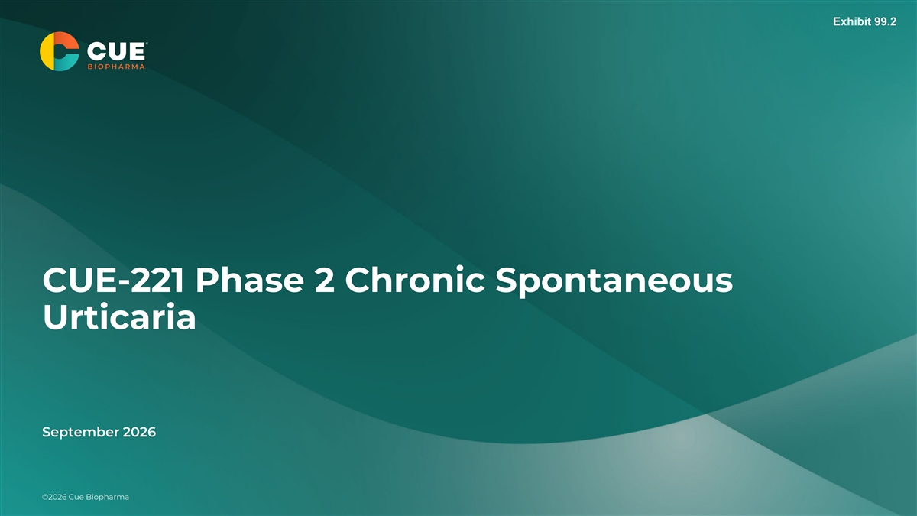
Exhibit 99.2 CUE-221 Phase 2 Chronic Spontaneous Urticaria September 2026 ©© 20 20 26 26 C C ue ue B B ioip oh pa hr a ma rma ©2024 Cue Biopharma CONFIDENTIAL DO NOT DISTRIBUTE

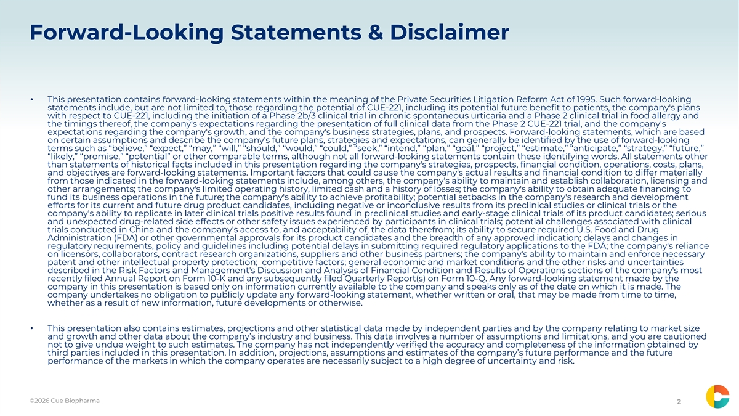
Forward-Looking Statements & Disclaimer • This presentation contains forward-looking statements within the meaning of the Private Securities Litigation Reform Act of 1995. Such forward-looking statements include, but are not limited to, those regarding the potential of CUE-221, including its potential future benefit to patients, the company's plans with respect to CUE-221, including the initiation of a Phase 2b/3 clinical trial in chronic spontaneous urticaria and a Phase 2 clinical trial in food allergy and the timings thereof, the company's expectations regarding the presentation of full clinical data from the Phase 2 CUE-221 trial, and the company's expectations regarding the company's growth, and the company's business strategies, plans, and prospects. Forward-looking statements, which are based on certain assumptions and describe the company's future plans, strategies and expectations, can generally be identified by the use of forward-looking terms such as “believe,” “expect,” “may,” “will,” “should,” “would,” “could,” “seek,” “intend,” “plan,” “goal,” “project,” “estimate,” “anticipate,” “strategy,” “future,” “likely,” “promise,” “potential” or other comparable terms, although not all forward-looking statements contain these identifying words. All statements other than statements of historical facts included in this presentation regarding the company's strategies, prospects, financial condition, operations, costs, plans, and objectives are forward-looking statements. Important factors that could cause the company's actual results and financial condition to differ materially from those indicated in the forward-looking statements include, among others, the company's ability to maintain and establish collaboration, licensing and other arrangements; the company's limited operating history, limited cash and a history of losses; the company's ability to obtain adequate financing to fund its business operations in the future; the company's ability to achieve profitability; potential setbacks in the company's research and development efforts for its current and future drug product candidates, including negative or inconclusive results from its preclinical studies or clinical trials or the company's ability to replicate in later clinical trials positive results found in preclinical studies and early-stage clinical trials of its product candidates; serious and unexpected drug-related side effects or other safety issues experienced by participants in clinical trials; potential challenges associated with clinical trials conducted in China and the company's access to, and acceptability of, the data therefrom; its ability to secure required U.S. Food and Drug Administration (FDA) or other governmental approvals for its product candidates and the breadth of any approved indication; delays and changes in regulatory requirements, policy and guidelines including potential delays in submitting required regulatory applications to the FDA; the company's reliance on licensors, collaborators, contract research organizations, suppliers and other business partners; the company's ability to maintain and enforce necessary patent and other intellectual property protection; competitive factors; general economic and market conditions and the other risks and uncertainties described in the Risk Factors and Management's Discussion and Analysis of Financial Condition and Results of Operations sections of the company's most recently filed Annual Report on Form 10-K and any subsequently filed Quarterly Report(s) on Form 10-Q. Any forward-looking statement made by the company in this presentation is based only on information currently available to the company and speaks only as of the date on which it is made. The company undertakes no obligation to publicly update any forward-looking statement, whether written or oral, that may be made from time to time, whether as a result of new information, future developments or otherwise. • This presentation also contains estimates, projections and other statistical data made by independent parties and by the company relating to market size and growth and other data about the company’s industry and business. This data involves a number of assumptions and limitations, and you are cautioned not to give undue weight to such estimates. The company has not independently verified the accuracy and completeness of the information obtained by CONFIDENTIAL third parties included in this presentation. In addition, projections, assumptions and estimates of the company’s future performance and the future performance of the markets in which the company operates are necessarily subject to a high degree of uncertainty and risk. CONFIDENTIAL ©2026 Cue Biopharma ©2024 Cue Biopharma CONFIDENTIAL DO NOT DISTRIBUTE 2

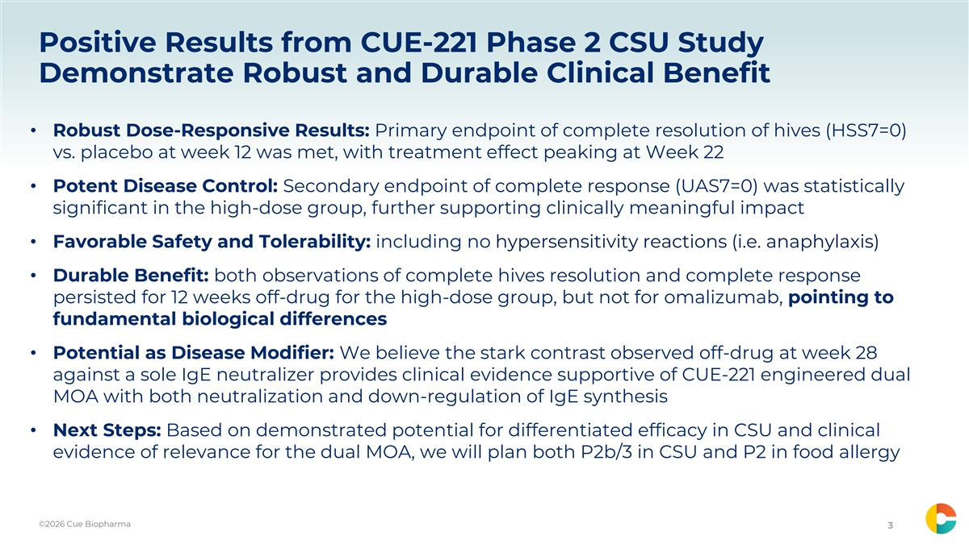
Positive Results from CUE-221 Phase 2 CSU Study Demonstrate Robust and Durable Clinical Benefit • Robust Dose-Responsive Results: Primary endpoint of complete resolution of hives (HSS7=0) vs. placebo at week 12 was met, with treatment effect peaking at Week 22 • Potent Disease Control: Secondary endpoint of complete response (UAS7=0) was statistically significant in the high-dose group, further supporting clinically meaningful impact • Favorable Safety and Tolerability: including no hypersensitivity reactions (i.e. anaphylaxis) • Durable Benefit: both observations of complete hives resolution and complete response persisted for 12 weeks off-drug for the high-dose group, but not for omalizumab, pointing to fundamental biological differences • Potential as Disease Modifier: We believe the stark contrast observed off-drug at week 28 against a sole IgE neutralizer provides clinical evidence supportive of CUE-221 engineered dual MOA with both neutralization and down-regulation of IgE synthesis • Next Steps: Based on demonstrated potential for differentiated efficacy in CSU and clinical evidence of relevance for the dual MOA, we will plan both P2b/3 in CSU and P2 in food allergy ©2026 Cue Biopharma ©2024 Cue Biopharma CONFIDENTIAL DO NOT DISTRIBUTE 3

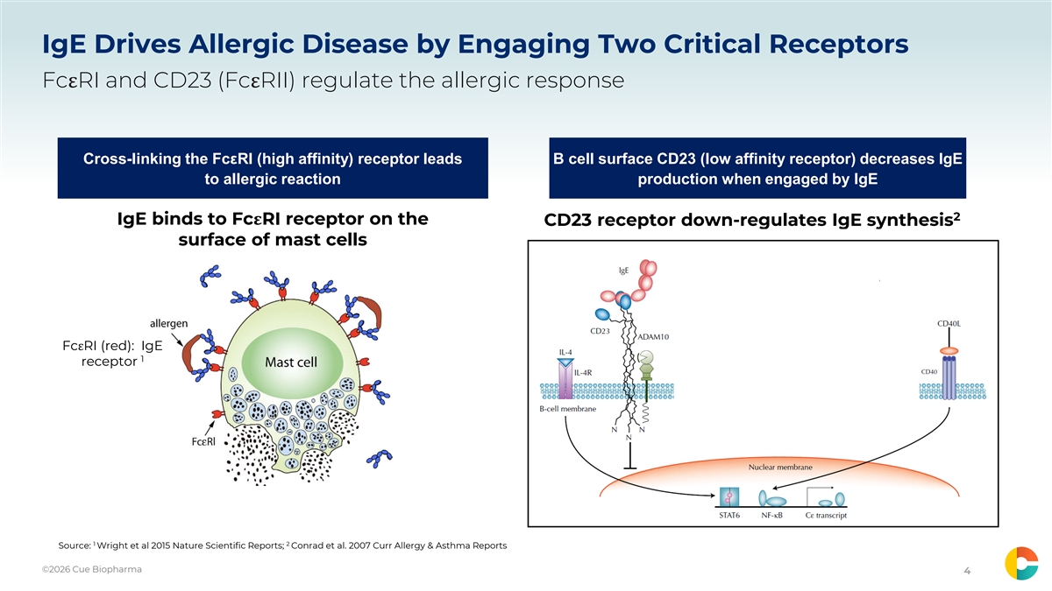
IgE Drives Allergic Disease by Engaging Two Critical Receptors FcεRI and CD23 (FcεRII) regulate the allergic response Cross-linking the FcεRI (high affinity) receptor leads B cell surface CD23 (low affinity receptor) decreases IgE to allergic reaction production when engaged by IgE 2 IgE binds to FcεRI receptor on the CD23 receptor down-regulates IgE synthesis surface of mast cells FcεRI (red): IgE 1 receptor 1 2 Source: Wright et al 2015 Nature Scientific Reports; Conrad et al. 2007 Curr Allergy & Asthma Reports ©2026 Cue Biopharma ©2024 Cue Biopharma CONFIDENTIAL DO NOT DISTRIBUTE 4

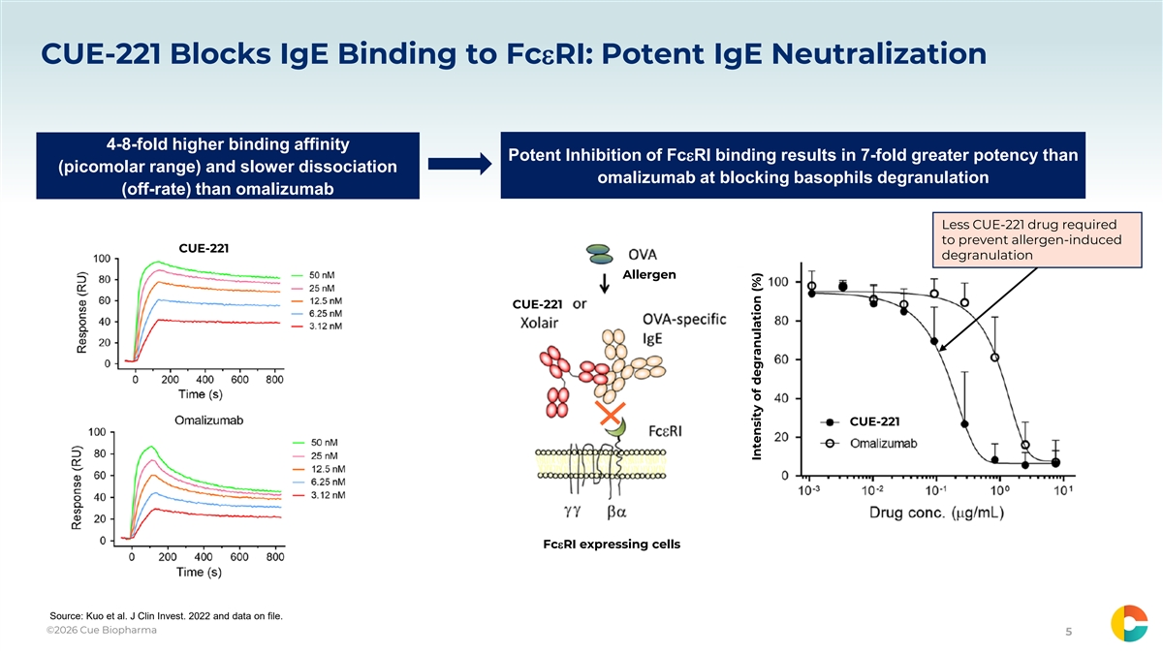
CUE-221 Blocks IgE Binding to FcεRI: Potent IgE Neutralization 4-8-fold higher binding affinity Potent Inhibition of FcεRI binding results in 7-fold greater potency than (picomolar range) and slower dissociation omalizumab at blocking basophils degranulation (off-rate) than omalizumab Less CUE-221 drug required to prevent allergen-induced CUE-221 degranulation Allergen CUE-221 CUE-221 FcεRI expressing cells Source: Kuo et al. J Clin Invest. 2022 and data on file. ©2026 Cue Biopharma ©2024 Cue Biopharma CONFIDENTIAL DO NOT DISTRIBUTE 5 Intensity of degranulation (%)

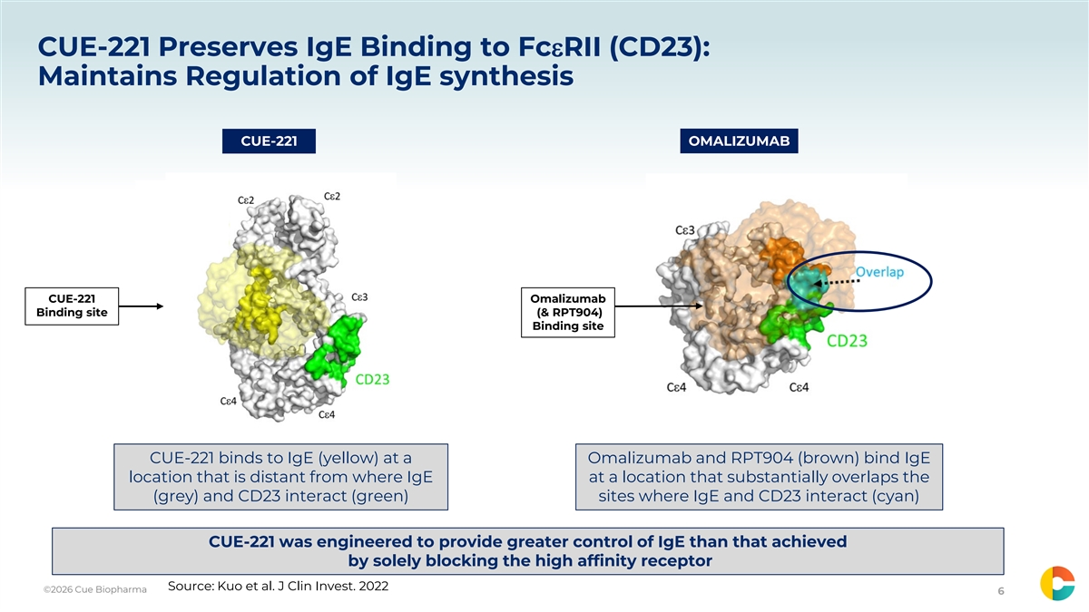
CUE-221 Preserves IgE Binding to FcεRII (CD23): Maintains Regulation of IgE synthesis CUE-221 OMALIZUMAB CUE-221 Omalizumab Binding site (& RPT904) Binding site CUE-221 binds to IgE (yellow) at a Omalizumab and RPT904 (brown) bind IgE location that is distant from where IgE at a location that substantially overlaps the (grey) and CD23 interact (green) sites where IgE and CD23 interact (cyan) CUE-221 was engineered to provide greater control of IgE than that achieved by solely blocking the high affinity receptor Source: Kuo et al. J Clin Invest. 2022 ©2026 Cue Biopharma ©2024 Cue Biopharma CONFIDENTIAL DO NOT DISTRIBUTE 6

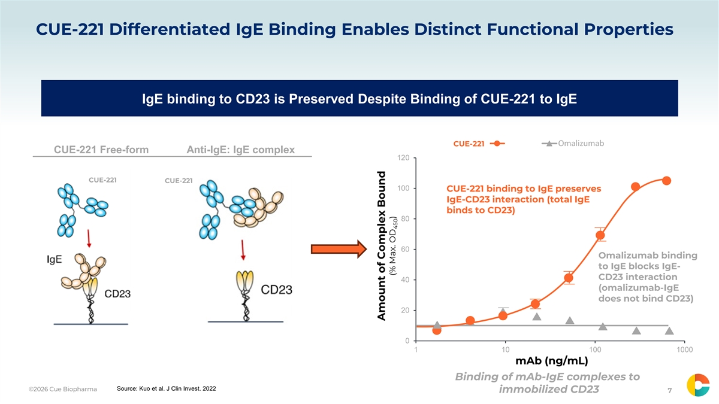
CUE-221 Differentiated IgE Binding Enables Distinct Functional Properties IgE binding to CD23 is Preserved Despite Binding of CUE-221 to IgE Omalizumab CUE-221 UB-221 CUE-221 Free-form Anti-IgE: IgE complex 120 CUE-221 CUE-221 100 CUE-221 binding to IgE preserves IgE-CD23 interaction (total IgE binds to CD23) 80 60 Omalizumab binding to IgE blocks IgE- CD23 interaction 40 (omalizumab-IgE does not bind CD23) 20 0 1 10 100 1000 mAb (ng/mL) Binding of mAb-IgE complexes to Source: Kuo et al. J Clin Invest. 2022 ©2026 Cue Biopharma ©2024 Cue Biopharma CONFIDENTIAL DO NOT DISTRIBUTE immobilized CD23 7 Amount of Complex Bound (% Max. OD ) 450

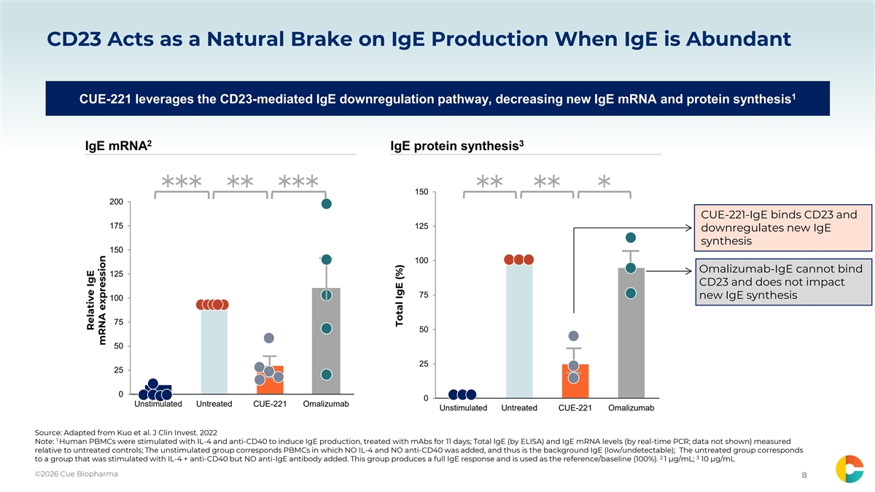
CD23 Acts as a Natural Brake on IgE Production When IgE is Abundant 1 CUE-221 leverages the CD23-mediated IgE downregulation pathway, decreasing new IgE mRNA and protein synthesis 2 3 IgE mRNA IgE protein synthesis 150 *** ** *** ** ** * 200 CUE-221-IgE binds CD23 and 175 125 downregulates new IgE synthesis 150 100 Omalizumab-IgE cannot bind 125 CD23 and does not impact 75 new IgE synthesis 100 75 50 50 25 25 0 0 Unstimulated Untreated CUE-221 Omalizumab Unstimulated Untreated CUE-221 Omalizumab Source: Adapted from Kuo et al. J Clin Invest. 2022 1 Note: Human PBMCs were stimulated with IL-4 and anti-CD40 to induce IgE production, treated with mAbs for 11 days; Total IgE (by ELISA) and IgE mRNA levels (by real-time PCR; data not shown) measured relative to untreated controls; The unstimulated group corresponds PBMCs in which NO IL-4 and NO anti-CD40 was added, and thus is the background IgE (low/undetectable); The untreated group corresponds 2 3 to a group that was stimulated with IL-4 + anti-CD40 but NO anti-IgE antibody added. This group produces a full IgE response and is used as the reference/baseline (100%). 1 µg/mL; 10 µg/mL ©2026 Cue Biopharma ©2024 Cue Biopharma CONFIDENTIAL DO NOT DISTRIBUTE 8 Relative IgE mRNA expression Total IgE (%)

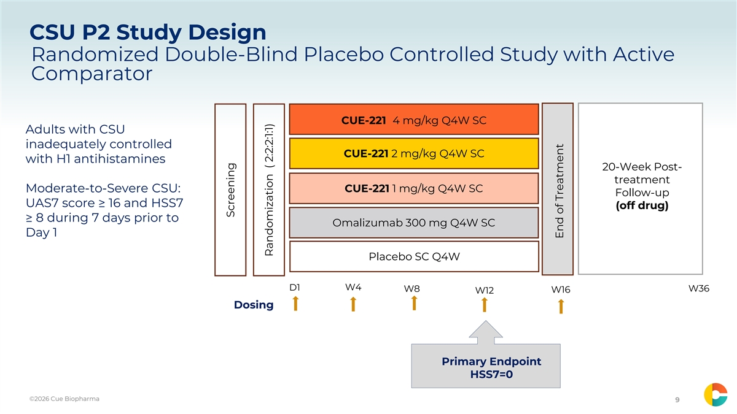
CSU P2 Study Design Randomized Double-Blind Placebo Controlled Study with Active Comparator CUE-221 4 mg/kg Q4W SC Adults with CSU inadequately controlled CUE-221 2 mg/kg Q4W SC with H1 antihistamines 20-Week Post- treatment Moderate-to-Severe CSU: CUE-221 1 mg/kg Q4W SC Follow-up UAS7 score ≥ 16 and HSS7 (off drug) ≥ 8 during 7 days prior to Omalizumab 300 mg Q4W SC Day 1 Placebo SC Q4W D1 W4 W8 W36 W16 W12 Dosing Primary Endpoint HSS7=0 ©2026 Cue Biopharma ©2024 Cue Biopharma CONFIDENTIAL DO NOT DISTRIBUTE 9 Screening Randomization ( 2:2:2:1:1) End of Treatment

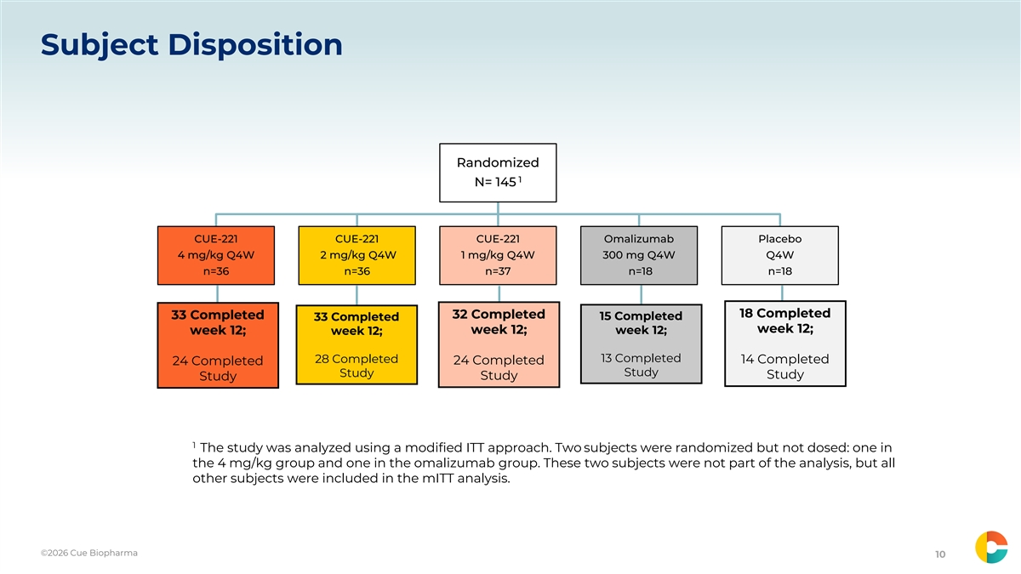
Subject Disposition Randomized 1 N= 145 CUE-221 CUE-221 CUE-221 Omalizumab Placebo 4 mg/kg Q4W 2 mg/kg Q4W 1 mg/kg Q4W 300 mg Q4W Q4W n=36 n=36 n=37 n=18 n=18 18 Completed 33 Completed 32 Completed 15 Completed 33 Completed week 12; week 12; week 12; week 12; week 12; 13 Completed 28 Completed 14 Completed 24 Completed 24 Completed Study Study Study Study Study 1 The study was analyzed using a modified ITT approach. Two subjects were randomized but not dosed: one in the 4 mg/kg group and one in the omalizumab group. These two subjects were not part of the analysis, but all other subjects were included in the mITT analysis. ©2026 Cue Biopharma ©2024 Cue Biopharma CONFIDENTIAL DO NOT DISTRIBUTE 10

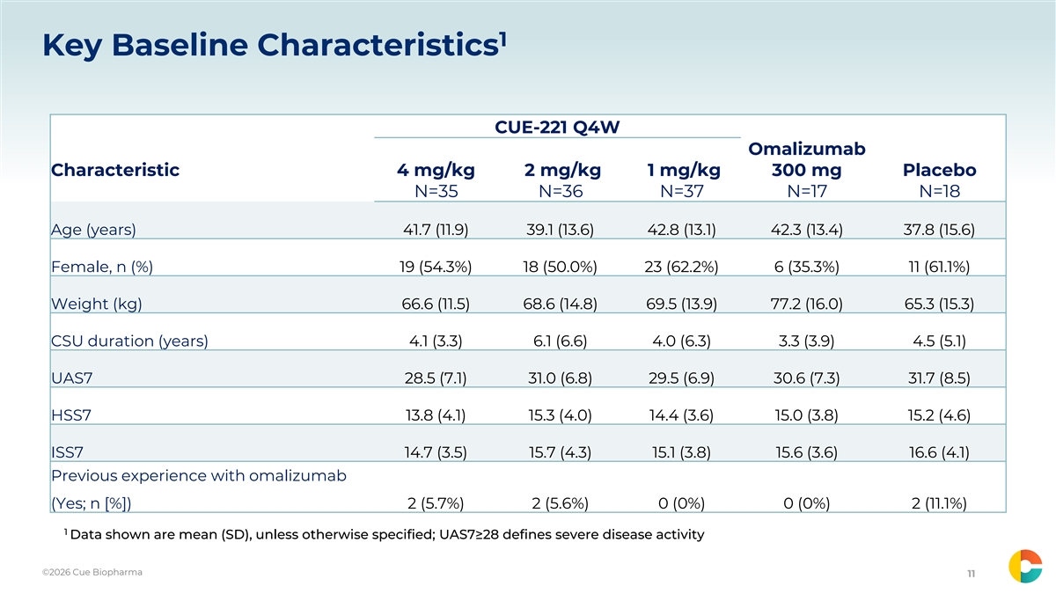
1 Key Baseline Characteristics CUE-221 Q4W Omalizumab Characteristic 4 mg/kg 2 mg/kg 1 mg/kg 300 mg Placebo N=35 N=36 N=37 N=17 N=18 Age (years) 41.7 (11.9) 39.1 (13.6) 42.8 (13.1) 42.3 (13.4) 37.8 (15.6) Female, n (%) 19 (54.3%) 18 (50.0%) 23 (62.2%) 6 (35.3%) 11 (61.1%) Weight (kg) 66.6 (11.5) 68.6 (14.8) 69.5 (13.9) 77.2 (16.0) 65.3 (15.3) CSU duration (years) 4.1 (3.3) 6.1 (6.6) 4.0 (6.3) 3.3 (3.9) 4.5 (5.1) UAS7 28.5 (7.1) 31.0 (6.8) 29.5 (6.9) 30.6 (7.3) 31.7 (8.5) HSS7 13.8 (4.1) 15.3 (4.0) 14.4 (3.6) 15.0 (3.8) 15.2 (4.6) ISS7 14.7 (3.5) 15.7 (4.3) 15.1 (3.8) 15.6 (3.6) 16.6 (4.1) Previous experience with omalizumab (Yes; n [%]) 2 (5.7%) 2 (5.6%) 0 (0%) 0 (0%) 2 (11.1%) 1 Data shown are mean (SD), unless otherwise specified; UAS7≥28 defines severe disease activity ©2026 Cue Biopharma ©2024 Cue Biopharma CONFIDENTIAL DO NOT DISTRIBUTE 11

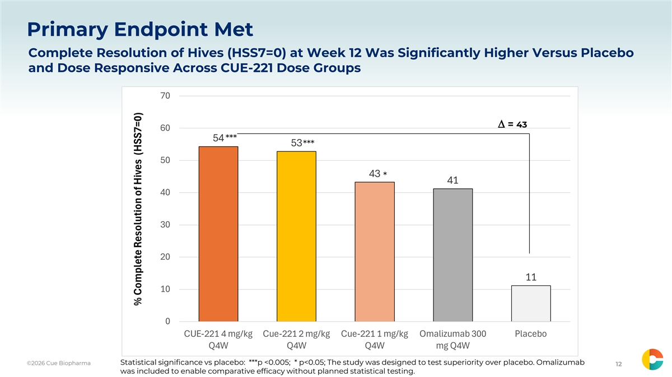
Primary Endpoint Met Complete Resolution of Hives (HSS7=0) at Week 12 Was Significantly Higher Versus Placebo and Dose Responsive Across CUE-221 Dose Groups 70 ∆ = 43 60 54 *** 53 *** 50 43 * 41 40 30 20 11 10 0 CUE-221 4 mg/kg Cue-221 2 mg/kg Cue-221 1 mg/kg Omalizumab 300 Placebo Q4W Q4W Q4W mg Q4W ©2026 Cue Biopharma Statistical significance vs placebo: ***p <0.005; * p<0.05; The study was designed to test superiority over placebo. Omalizumab ©2024 Cue Biopharma CONFIDENTIAL DO NOT DISTRIBUTE 12 was included to enable comparative efficacy without planned statistical testing. % Complete Resolution of Hives (HSS7=0)

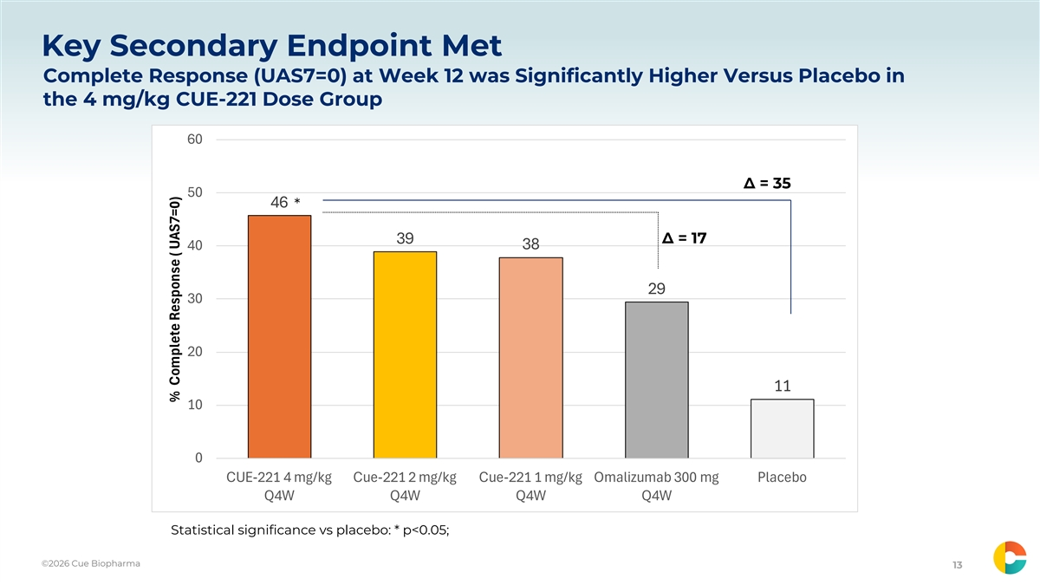
Key Secondary Endpoint Met Complete Response (UAS7=0) at Week 12 was Significantly Higher Versus Placebo in the 4 mg/kg CUE-221 Dose Group 60 ∆ = 35 50 46 * 39 ∆ = 17 38 40 29 30 20 11 10 0 CUE-221 4 mg/kg Cue-221 2 mg/kg Cue-221 1 mg/kg Omalizumab 300 mg Placebo Q4W Q4W Q4W Q4W Statistical significance vs placebo: * p<0.05; ©2026 Cue Biopharma ©2024 Cue Biopharma CONFIDENTIAL DO NOT DISTRIBUTE 13 % Complete Response ( UAS7=0)

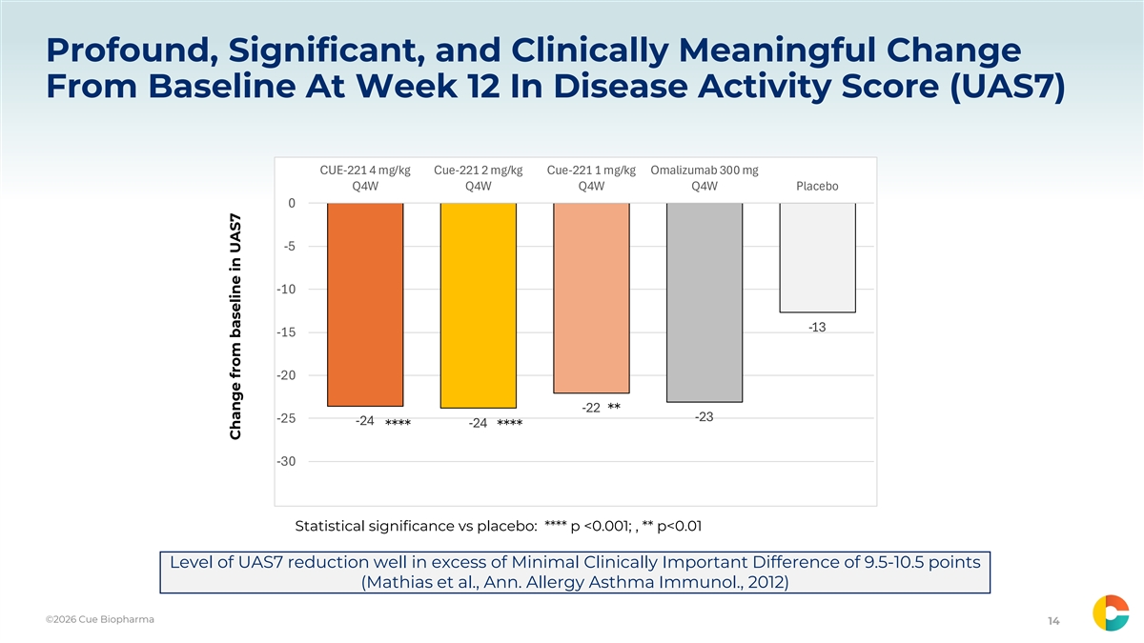
Profound, Significant, and Clinically Meaningful Change From Baseline At Week 12 In Disease Activity Score (UAS7) CUE-221 4 mg/kg Cue-221 2 mg/kg Cue-221 1 mg/kg Omalizumab 300 mg Q4W Q4W Q4W Q4W Placebo 0 -5 -10 -13 -15 -20 -22 ** -23 -25 -24 -24 **** **** -30 Statistical significance vs placebo: **** p <0.001; , ** p<0.01 Level of UAS7 reduction well in excess of Minimal Clinically Important Difference of 9.5-10.5 points (Mathias et al., Ann. Allergy Asthma Immunol., 2012) ©2026 Cue Biopharma ©2024 Cue Biopharma CONFIDENTIAL DO NOT DISTRIBUTE 14 Change from baseline in UAS7

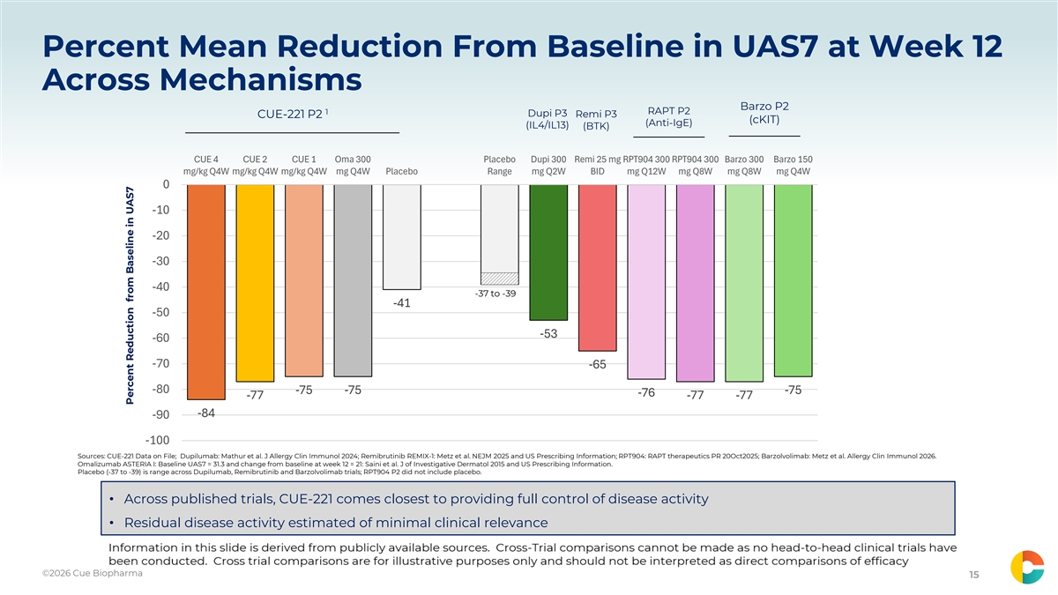
Percent Mean Reduction From Baseline in UAS7 at Week 12 Across Mechanisms Barzo P2 1 RAPT P2 Dupi P3 CUE-221 P2 Remi P3 (cKIT) (Anti-IgE) (IL4/IL13) (BTK) CUE 4 CUE 2 CUE 1 Oma 300 Placebo Dupi 300 Remi 25 mg RPT904 300 RPT904 300 Barzo 300 Barzo 150 mg/kg Q4W mg/kg Q4W mg/kg Q4W mg Q4W Placebo Range mg Q2W BID mg Q12W mg Q8W mg Q8W mg Q4W 0 -10 -20 -30 -40 -37 to -39 -41 -50 -53 -60 -70 -65 -80 -75 -75 -75 -76 -77 -77 -77 -84 -90 -100 Sources: CUE-221 Data on File; Dupilumab: Mathur et al. J Allergy Clin Immunol 2024; Remibrutinib REMIX-1: Metz et al. NEJM 2025 and US Prescribing Information; RPT904: RAPT therapeutics PR 20Oct2025; Barzolvolimab: Metz et al. Allergy Clin Immunol 2026. Omalizumab ASTERIA I: Baseline UAS7 = 31.3 and change from baseline at week 12 = 21: Saini et al. J of Investigative Dermatol 2015 and US Prescribing Information. Placebo (-37 to -39) is range across Dupilumab, Remibrutinib and Barzolvolimab trials; RPT904 P2 did not include placebo. • Across published trials, CUE-221 comes closest to providing full control of disease activity • Residual disease activity estimated of minimal clinical relevance ©2026 Cue Biopharma ©2024 Cue Biopharma CONFIDENTIAL DO NOT DISTRIBUTE 15 Percent Reduction from Baseline in UAS7

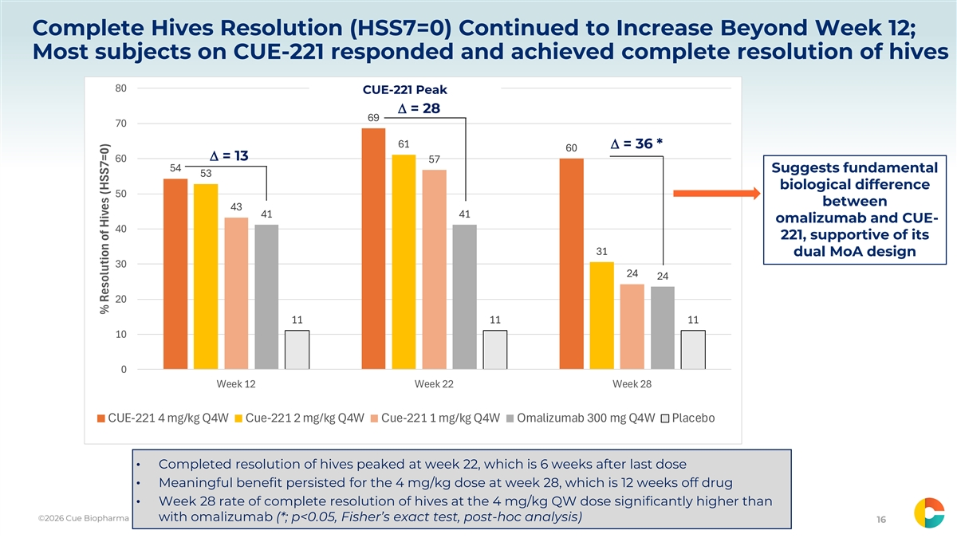
Complete Hives Resolution (HSS7=0) Continued to Increase Beyond Week 12; Most subjects on CUE-221 responded and achieved complete resolution of hives 80 CUE-221 Peak ∆ = 28 69 70 61 ∆ = 36 * 60 ∆ = 13 60 57 54 Suggests fundamental 53 biological difference 50 between 43 41 41 omalizumab and CUE- 40 221, supportive of its 31 dual MoA design 30 24 24 20 11 11 11 10 0 Week 12 Week 22 Week 28 CUE-221 4 mg/kg Q4W Cue-221 2 mg/kg Q4W Cue-221 1 mg/kg Q4W Omalizumab 300 mg Q4W Placebo • Completed resolution of hives peaked at week 22, which is 6 weeks after last dose • Meaningful benefit persisted for the 4 mg/kg dose at week 28, which is 12 weeks off drug • Week 28 rate of complete resolution of hives at the 4 mg/kg QW dose significantly higher than ©2026 Cue Biopharma with omalizumab (*; p<0.05, Fisher’s exact test, post-hoc analysis) ©2024 Cue Biopharma CONFIDENTIAL DO NOT DISTRIBUTE 16 % Resolution of Hives (HSS7=0)

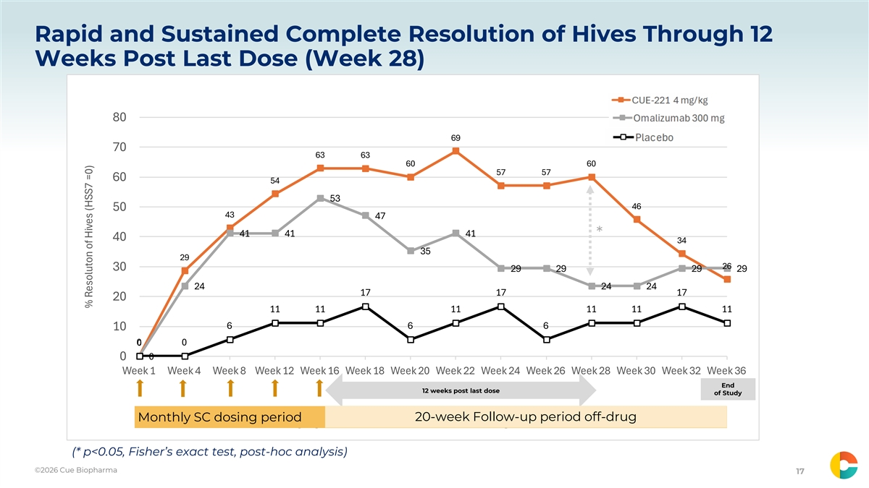
Rapid and Sustained Complete Resolution of Hives Through 12 Weeks Post Last Dose (Week 28) 80 69 70 63 63 60 60 57 57 60 54 53 46 50 43 47 41 41 41 * 40 34 35 29 26 30 29 29 29 29 24 24 24 17 17 17 20 11 11 11 11 11 11 6 6 6 10 0 0 0 0 0 Week 1 Week 4 Week 8 Week 12 Week 16 Week 18 Week 20 Week 22 Week 24 Week 26 Week 28 Week 30 Week 32 Week 36 End 12 weeks post last dose of Study 20-week Follow-up period off-drug Monthly SC dosing period 20-week Follow-up period off-drug CUE-221 4 mg/kg Q4W Omalizumab 300 mg Q4W Placebo (* p<0.05, Fisher’s exact test, post-hoc analysis) ©2026 Cue Biopharma ©2024 Cue Biopharma CONFIDENTIAL DO NOT DISTRIBUTE 17 % Resoluton of Hives (HSS7 =0)

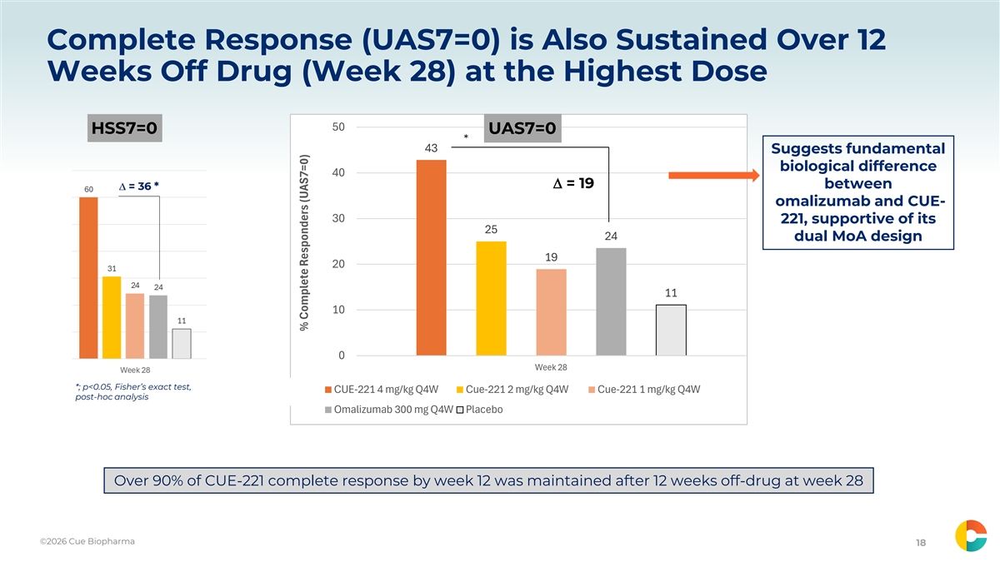
Complete Response (UAS7=0) is Also Sustained Over 12 Weeks Off Drug (Week 28) at the Highest Dose 50 HSS7=0 UAS7=0 * 43 Suggests fundamental biological difference 40 ∆ = 19 between omalizumab and CUE- 30 221, supportive of its 25 24 dual MoA design 19 20 11 10 0 Week 28 *; p<0.05, Fisher’s exact test, CUE-221 4 mg/kg Q4W Cue-221 2 mg/kg Q4W Cue-221 1 mg/kg Q4W post-hoc analysis Omalizumab 300 mg Q4W Placebo Over 90% of CUE-221 complete response by week 12 was maintained after 12 weeks off-drug at week 28 ©2026 Cue Biopharma ©2024 Cue Biopharma CONFIDENTIAL DO NOT DISTRIBUTE 18 % Complete Responders (UAS7=0)

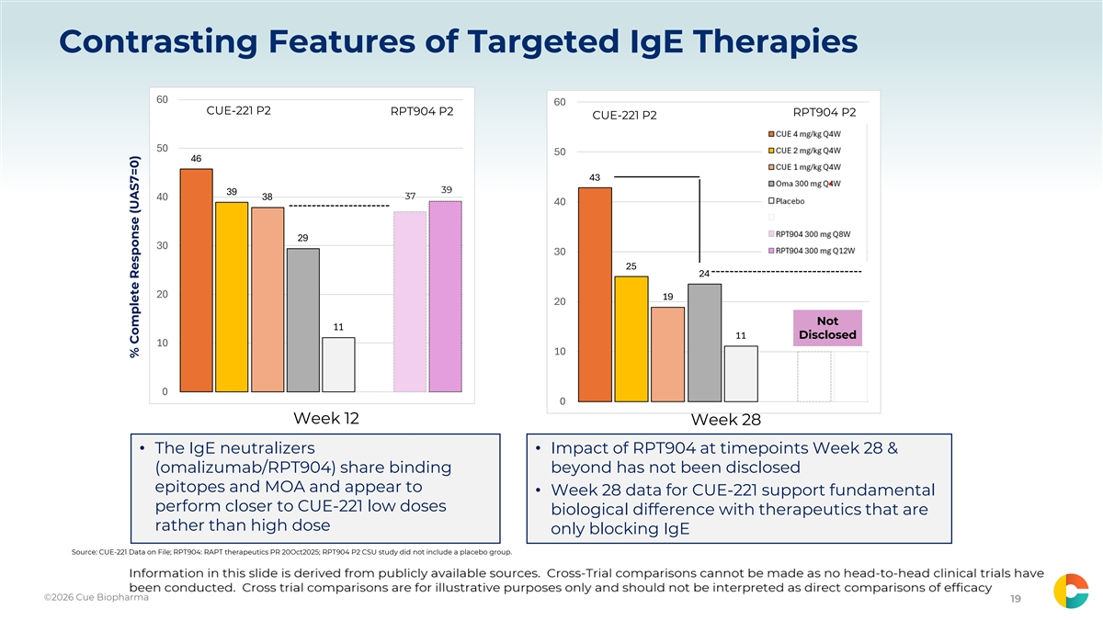
Contrasting Features of Targeted IgE Therapies 60 60 CUE-221 P2 RPT904 P2 RPT904 P2 CUE-221 P2 RPT904 P2 50 50 46 43 39 39 38 37 40 40 29 30 30 25 24 20 19 20 Not 11 11 Disclosed 10 10 0 0 Week 12 Week 28 • The IgE neutralizers • Impact of RPT904 at timepoints Week 28 & (omalizumab/RPT904) share binding beyond has not been disclosed epitopes and MOA and appear to • Week 28 data for CUE-221 support fundamental perform closer to CUE-221 low doses biological difference with therapeutics that are rather than high dose only blocking IgE Source: CUE-221 Data on File; RPT904: RAPT therapeutics PR 20Oct2025; RPT904 P2 CSU study did not include a placebo group. ©2026 Cue Biopharma ©2024 Cue Biopharma CONFIDENTIAL DO NOT DISTRIBUTE 19 % Complete Response (UAS7=0)

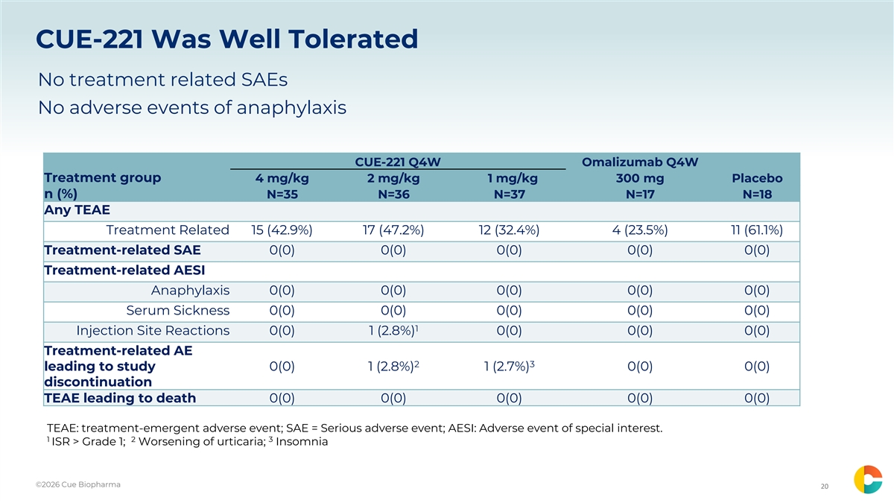
CUE-221 Was Well Tolerated No treatment related SAEs No adverse events of anaphylaxis CUE-221 Q4W Omalizumab Q4W Treatment group 4 mg/kg 2 mg/kg 1 mg/kg 300 mg Placebo n (%) N=35 N=36 N=37 N=17 N=18 Any TEAE Treatment Related 15 (42.9%) 17 (47.2%) 12 (32.4%) 4 (23.5%) 11 (61.1%) Treatment-related SAE 0(0) 0(0) 0(0) 0(0) 0(0) Treatment-related AESI Anaphylaxis 0(0) 0(0) 0(0) 0(0) 0(0) Serum Sickness 0(0) 0(0) 0(0) 0(0) 0(0) 1 Injection Site Reactions 0(0) 1 (2.8%) 0(0) 0(0) 0(0) Treatment-related AE 2 3 leading to study 0(0) 1 (2.8%) 1 (2.7%) 0(0) 0(0) discontinuation TEAE leading to death 0(0) 0(0) 0(0) 0(0) 0(0) TEAE: treatment-emergent adverse event; SAE = Serious adverse event; AESI: Adverse event of special interest. 1 2 3 ISR > Grade 1; Worsening of urticaria; Insomnia ©2026 Cue Biopharma ©2024 Cue Biopharma CONFIDENTIAL DO NOT DISTRIBUTE 20

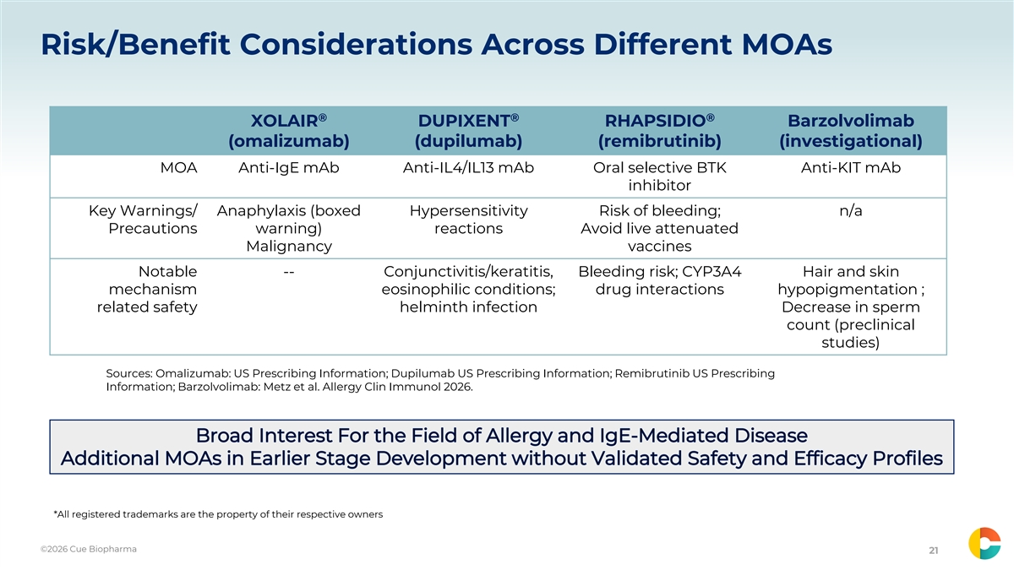
Risk/Benefit Considerations Across Different MOAs ® ® ® XOLAIR DUPIXENT RHAPSIDIO Barzolvolimab (omalizumab) (dupilumab) (remibrutinib) (investigational) MOA Anti-IgE mAb Anti-IL4/IL13 mAb Oral selective BTK Anti-KIT mAb inhibitor Key Warnings/ Anaphylaxis (boxed Hypersensitivity Risk of bleeding; n/a Precautions warning) reactions Avoid live attenuated Malignancy vaccines Notable -- Conjunctivitis/keratitis, Bleeding risk; CYP3A4 Hair and skin mechanism eosinophilic conditions; drug interactions hypopigmentation ; related safety helminth infection Decrease in sperm count (preclinical studies) Sources: Omalizumab: US Prescribing Information; Dupilumab US Prescribing Information; Remibrutinib US Prescribing Information; Barzolvolimab: Metz et al. Allergy Clin Immunol 2026. *All registered trademarks are the property of their respective owners ©2026 Cue Biopharma ©2024 Cue Biopharma CONFIDENTIAL DO NOT DISTRIBUTE 21

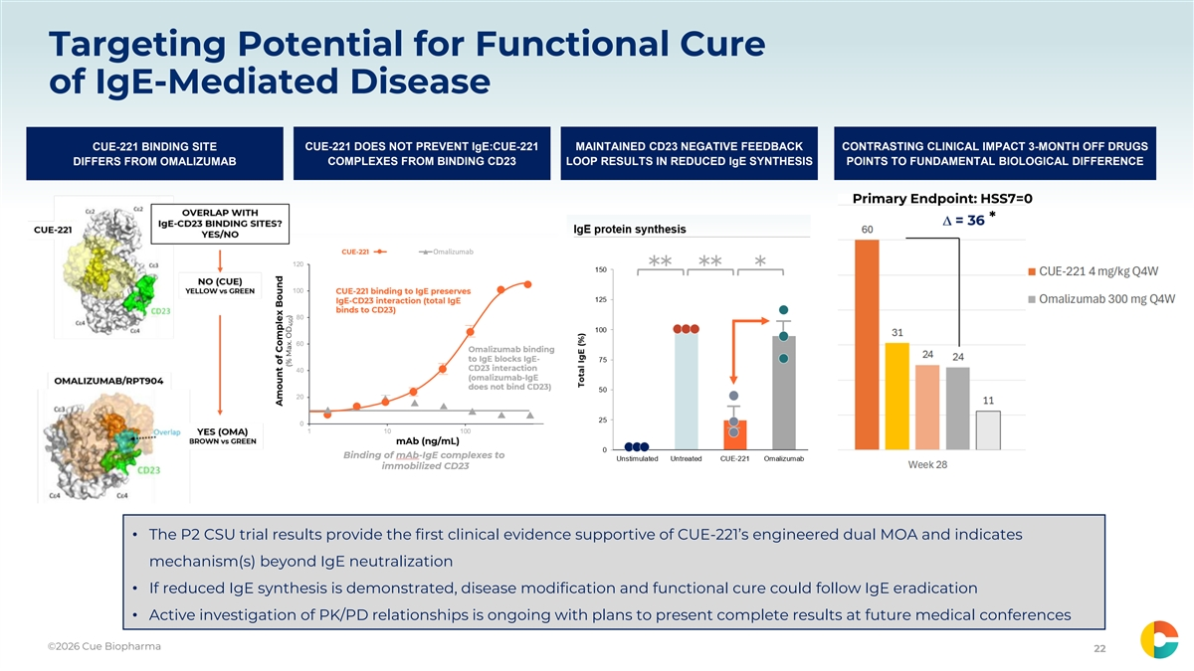
Targeting Potential for Functional Cure of IgE-Mediated Disease CUE-221 BINDING SITE CUE-221 DOES NOT PREVENT IgE:CUE-221 MAINTAINED CD23 NEGATIVE FEEDBACK CONTRASTING CLINICAL IMPACT 3-MONTH OFF DRUGS DIFFERS FROM OMALIZUMAB COMPLEXES FROM BINDING CD23 LOOP RESULTS IN REDUCED IgE SYNTHESIS POINTS TO FUNDAMENTAL BIOLOGICAL DIFFERENCE Primary Endpoint: HSS7=0 * • The P2 CSU trial results provide the first clinical evidence supportive of CUE-221’s engineered dual MOA and indicates mechanism(s) beyond IgE neutralization • If reduced IgE synthesis is demonstrated, disease modification and functional cure could follow IgE eradication • Active investigation of PK/PD relationships is ongoing with plans to present complete results at future medical conferences ©2026 Cue Biopharma ©2024 Cue Biopharma CONFIDENTIAL DO NOT DISTRIBUTE 22

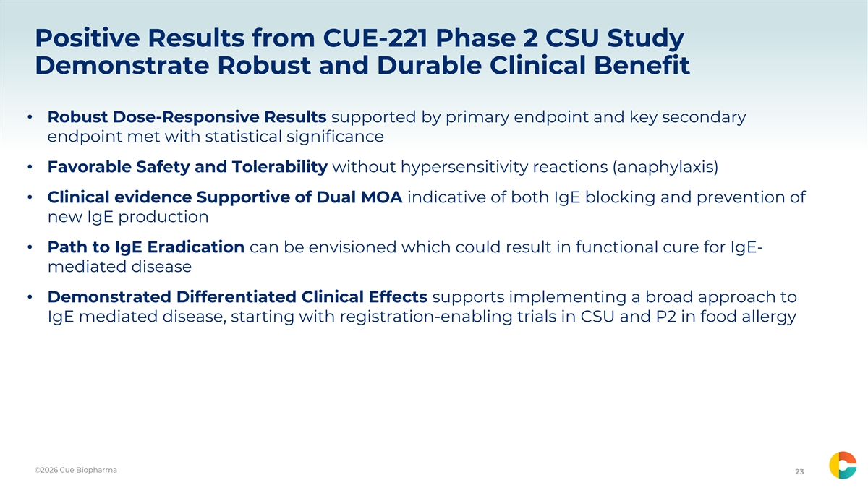
Positive Results from CUE-221 Phase 2 CSU Study Demonstrate Robust and Durable Clinical Benefit • Robust Dose-Responsive Results supported by primary endpoint and key secondary endpoint met with statistical significance • Favorable Safety and Tolerability without hypersensitivity reactions (anaphylaxis) • Clinical evidence Supportive of Dual MOA indicative of both IgE blocking and prevention of new IgE production • Path to IgE Eradication can be envisioned which could result in functional cure for IgE- mediated disease • Demonstrated Differentiated Clinical Effects supports implementing a broad approach to IgE mediated disease, starting with registration-enabling trials in CSU and P2 in food allergy ©2026 Cue Biopharma ©2024 Cue Biopharma CONFIDENTIAL DO NOT DISTRIBUTE 23

